Ushering the Year of the Rooster
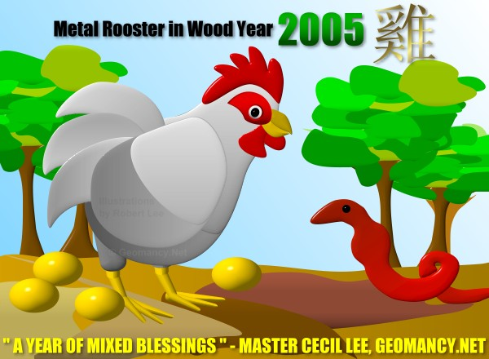

Q: What sort of rooster year is 2005? (Fire? etc?)

This is the Metal Rooster in Wood Year 2005 and is a year of mixed blessings.

It is favourable for the IT, Communications and Finance industry but unfavourable for the construction industry.

Q: What will the political scene be like for the world/region/Singapore?

It will be a period of continued violence and instability in the middle east and Iraq.

And closer to home, expect political instability in Thailand and Mynmar.

Otherwise, other Asian economies (other than Indonesia) will enjoy continued growth and progress for this year.

Q: What will the year be like for people born in the rooster year? What about for the other 11 animals signs (briefly)?

It is a mixed blessing for those born in the Rooster year depending on when they were born:-

1. Water Roosters (1933, 1993) will have to be extra careful this year.
2. Wood Roosters (1945, 2005) will do well this year.
3. Fire Roosters (1897, 1957) will do pretty well this year.
4. Earth Roosters (1909, 1969) will have to watch out this year.
5. Metal Roosters (1921, 1981) is a good year for them.

This is an excellent year for those born in the Ox, Snake and Dragon years.

This is not a good year for Rabbit, Dog and Roosters in general.

Under the Five Elements concept each of us are born as weak or strong element: Metal, Water, Wood, Fire and Earth.

Thus for 2005, it is a good year for those born with Strong Water, weak Wood, weak Fire elements.

But inauspicious for those born with weak Water, Strong Fire, weak Earth elements.

In general:-
1. Rat - Average. Watch out for Health issues.
2. ox - Good. Have some Unexpected Wealth but beware of Career / Health issues.
3. Tiger - Average. Wealth opportunities, beware of competitors.
4. Rabbit - Bad. Watch out for Health / beware of being betrayed by Friends.
5. Dragon - GOod. Have wealth opportunities / Friends will help you
6. Snake - Good. Have wealth opportunities / Career / Romance
7. Horse - Average. Beware of unexpected wealth / Love issues
8. Ram - Average. Have wealth gains / Beware of having being betrayed by Friends / Love-life
9. Monkey - Average. Have Finance / Career gains, beware about Health
10. Rooster - Bad. Beware of Competition / Career
11. Dog - Bad, Beware of Finance / Love
12. Pig - Average. Beware of Heath / Competition.

More details can be found at our 2005 Yearly Forecast

URL: http://www.geomancy.net/resources/yearly-forecast/fortunes-2005.htm

Q: Any stock market predictions?

Expect an active year in the stock market. Expect bullish activities in Chinese 11th and 12th month of 2005.

Q: When may the Singapore general elections take place according to your readings?

Between late 2005 to early 2006.

Q: Is it a good year for marriage/procreation?

So long as an auspicious date is selected, generally, it should be ok for most couples people.

It would be good for those born in the Rabbit, Dog and Rooster to consider delaying a year or so of marriage.

Q: What will the general tone of the year be like?

NOTE: Chinese Months

Chinese Month – Animal Sign Summary Element – Overall Summary
1st Month (Tiger) -> Average (Earth) -> Mixed-Blessing
2nd Month (Rabbit) -> Bad (Earth) -> Mixed-Blessing
3rd Month (Dragon) -> Good (Metal) -> Average
4th Month (Snake) -> Good (Metal) - Average
5th Month (Horse) -> Average (Water) -> Good
6th Month (Ram) -> Average (Water) -> Good
7th Month (Monkey) -> Average (Wood) -> Good
8th Month (Rooster) -> Bad (Wood) -> Average
9th Month (Dog) -> Bad (Fire) -> Bad
10th Month (Pig) -> Average (Fire) -> Bad
11th Month (Rat) -> Average (Earth) - Mixed-Blessing
12th Month (Ox) -> Good (Earth) - Mixed-Blessing

Q: Will it be a peaceful year or plagued by natural disasters (if so, of what nature)?

A year of Mixed-blessings plagued by earthquakes and floods.

Q: It being a "blind year", are marriages to be avoided at all costs, and the attendance of marriages?

Generally, as long as the best possible auspicious date is selected it should not be a problem.
Mainly, for those born in Rabbit, Dog, Rooster, they should try to avoid marrying this year. (Attending marriages is generally not a big issue. But, in any case, these three are the ones that should take extra caution or if possible avoid attendance of marriages).

Q: Is it a good year for travel?

This is an average year for travel. (There is no specific good movement star in the Chinese zodiac for this year). Therefore no real significance (good or bad) for travel.

Generally, good travel directions this year is the North (Water), East (Wood) and South-East (Wood).

Q: Which industries will thrive in the coming year?

In particular "Water" and "metal" related industries would thrive in this coming year. For example:

Water Industries
Advertising, Arts, Brewing, Communications, Computers, Drinks, Healing, Laundry,
Literature, Manufacturing, Media, Music, Therapy

Metal Industries
Accountacy, banking, coin mintage, entertainment, finance, hardware, investment, loans,
management consultancy, mechanical engineering

Other miscellaneous information for the home:-
Sickness Star this year is at East
Misfortune/Sickness Star this year is at North-East
Disputes/Quarrel Star this year is at South-West
Education/Romance Star this year is at Center

Grand Duke this year is West, 270 Degree.
- Avoid sitting facing the grand duke or disturbing him by having renovations.

Location in Conflict is East.
- Avoid having renovations done opposite the location in conlict.

About Master Cecil Lee

URL: http://www.geomancy.net/about/company/about-cecil.htm

Warmest Regards,
Cecil Lee
Principal Consultant and Founder
GEOMANCY.NET: Center for Applied Feng Shui Research
http://www.geomancy.net
E-mail: support@geomancy.net, 24 Hours HOTLINE : +65 6100-9600
ONE-STOP 24 Hours International Hotline : +65 6100-9600
SMS / MMS: +65 9785-3171 Fax: +65 6482-0570

